GTB  
  
**QA**  
[DEV 20.16] OT-853 | XT | UK | AS | 3.0 Popin - Mach-E BP-A (935)

**Jira ticket:**

**UPDATE:** <https://jira.uhub.biz/browse/GTBEMEAOPT-935>  
<https://jira.uhub.biz/browse/GTBEMEAOPT-853>

**Site**  
<https://www.ford.co.uk/>

**Test location**  
Across ford.co.uk - apart from E-comm configurator, E-comm Pre-order Journey, 1.0 Configurator and TDR

**Hypothesis**  
Analysis on the TDR Popin and UC5 has shown that TDR Popin converts at a higher rate than UC5 for TDR Completes. As such, we want to turn off UC5 and add the only vehicle included in UC5 in TDR Popin. Consolidating the two will also allow us to perform future AB testing to ensure TDR Popin is the best version it can be.

**Test Description**

View the QA link. Mouse over the Vehicles link in the main heading. Scroll down and select the **Mustang Mach-E.** From here click on the “*Pre-Order*” or “*Pre-Order Now*” buttons. You have now started the **Build and Price journey**.

The popup will now be able to appear if you leave this page now.   
“<https://www.ford.co.uk>” to go to the home page, the popup will appear in roughly 15 seconds.

The Popup should look something the below

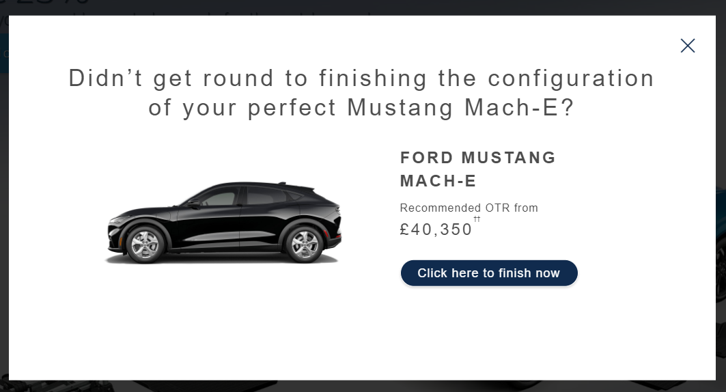

The mini popup should look like the below:  
  
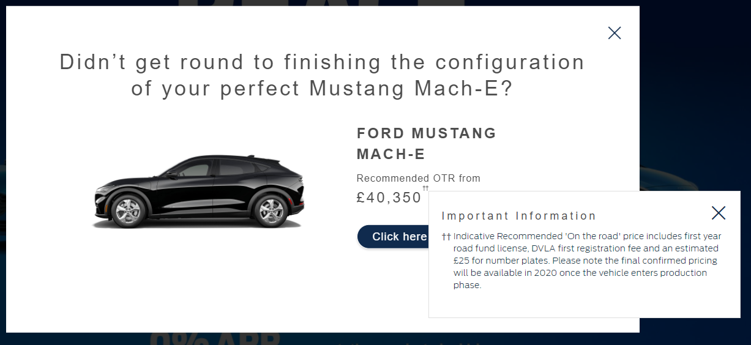

The **CTA button** should take you back to the Build and Price journey, but put you on the next step if possible.

Listing possible locations based on where you left below:  
  
Left Intro, CTA returns to Model  
Left Model, CTA returns to Model  
Left Range, CTA returns to Range  
Left Colour, CTA returns to Interior  
Left Interior, CTA returns to Extras  
Left Extras, CTA returns to Extras  
  
The above “left” sequence is ordered by how you would normally go through it, I.E. after clicking the Build your own on the intro page, it would take you to the model, selecting something on model would take you to range and so on.

Model and Range takes you back to those pages, as it requires a user selection to continue.  
Extras takes you back to Extras as the next page is the summary page.

If you were to browse through the entire journey and reach the summary page. If you then left the summary page there wouldn’t be a popup.  
  
**Browser:**   
All  
  
**Device:**   
All  
  
**Audience rules:**   
All traffic

**QA Links:**

<https://www.ford.co.uk/cars/mustang-mach-e?at_preview_token=DIPnBRyl90Zo_Y65Yrqlwg&at_preview_index=1_1&at_preview_listed_activities_only=true>